First insights from modelling starch digestion in the presence of inhibitors
George van Aken, 4 april 2023

Types of reversibele inhibitors:
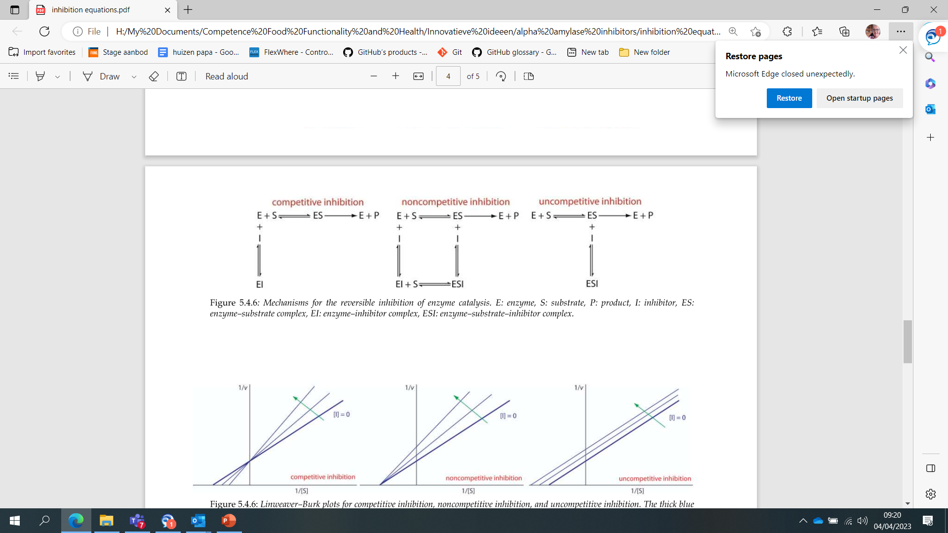
IC₅₀ = 50 μg/ml in 250 ml water given with the meals corresponds to 10 mg inhibitor;
100 x IC₅₀ = 5 mg/ml in 250 ml water given with the meals corresponds to 1.25 g inhibior.

Starch in solid meals:
- 50 g glucose + 250 ml water; pH 7; maximum consumptie speed 50 ml/min.
- 132 g bread (67 g water 50 g RDS, 9 g fat, 6 g protein) + 250 ml water; pH 7; maximum consumptive speed 50 ml/min.
- 132 g bread (67 g water 50 g RDS, 9 g fat, 6 g protein) + 250 ml water + inhibitor ; pH 7; maximum consumptie speed 50 ml/min.

Competitive amylase inhibitor; concentration at IC₅₀ in the water
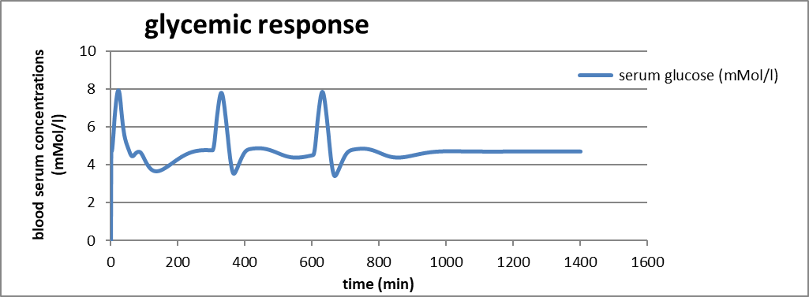
50 g
Glucose
132 g
bread
132 g
bread + inhibitor
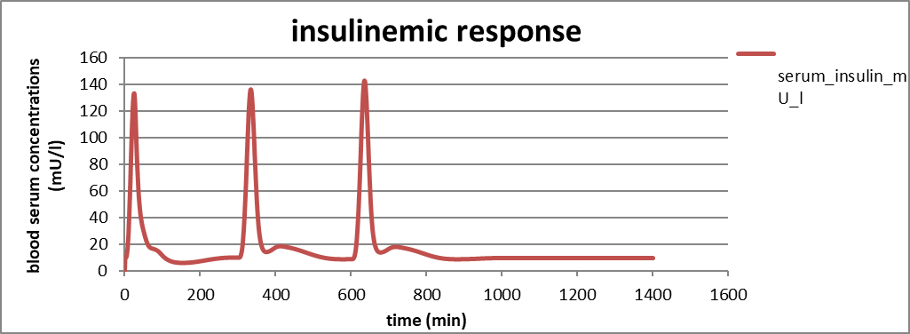

Competitive amylase inhibitor; concentration 100 x IC₅₀ in water
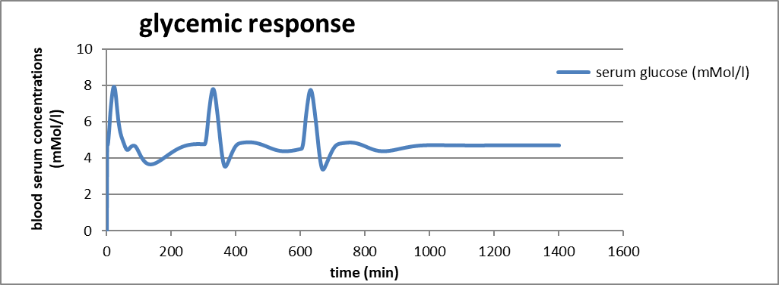
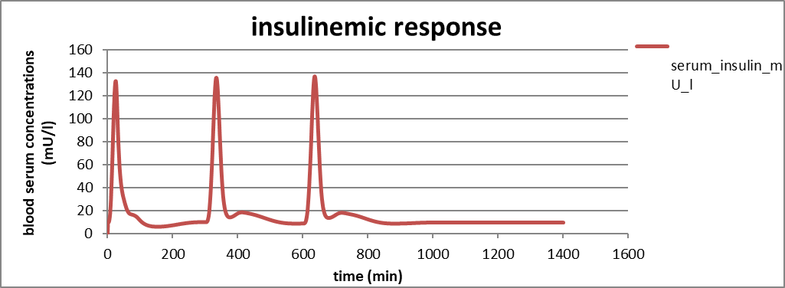
Non-competitive amylase inhibitor; concentration IC₅₀ in water

Non-competitive amylase inhibitor; concentration 100 x IC₅₀ in water
Uncompetitive amylase inhibitor; concentration IC₅₀ in water
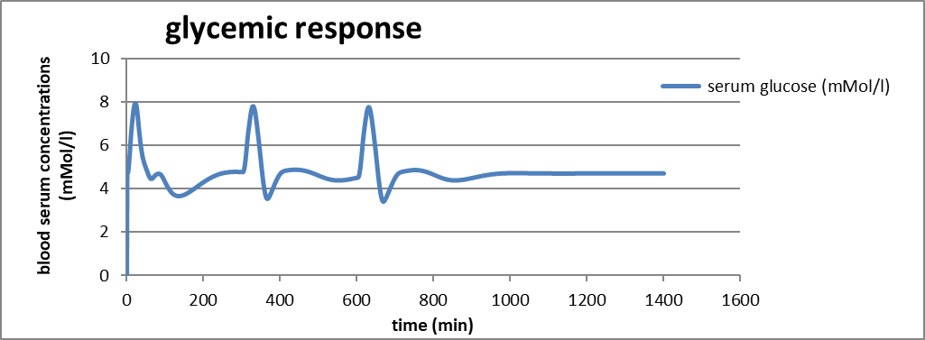
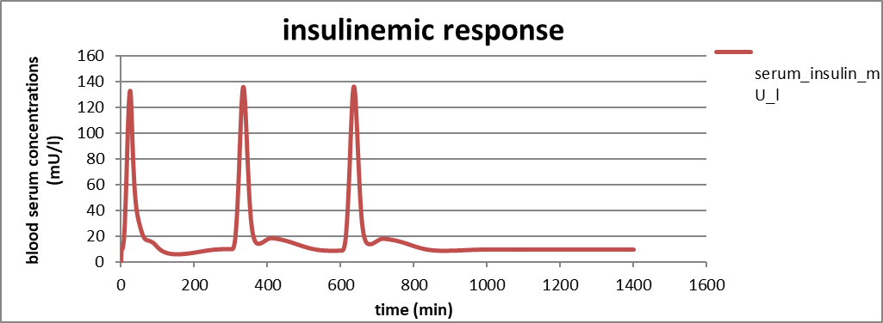
Uncompetitive amylase inhibitor; concentration 100 x IC₅₀ in water
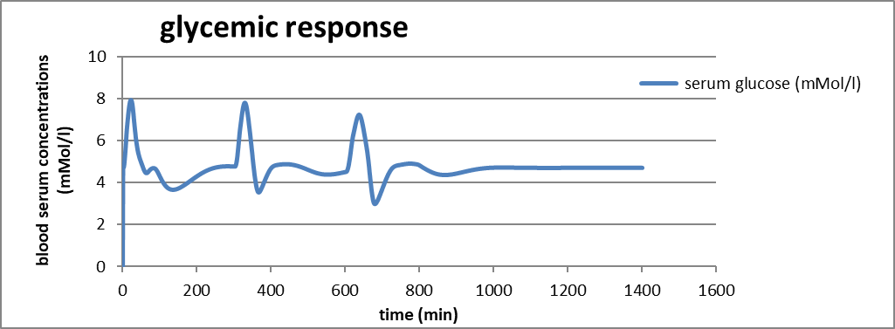
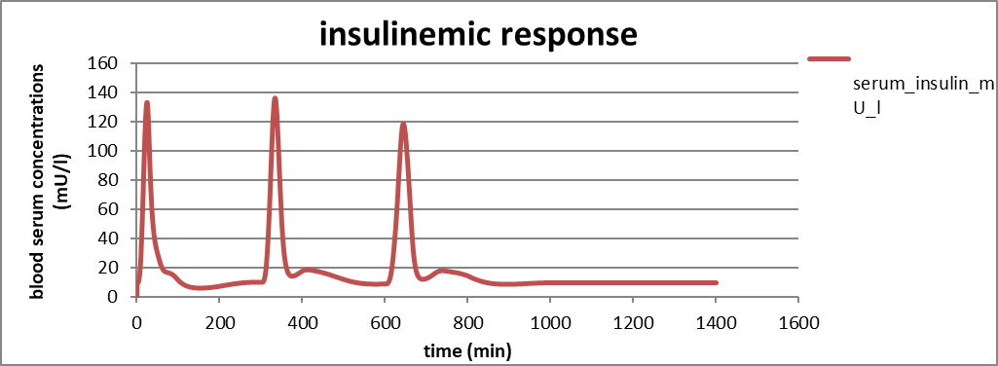
Starch in solid meals:
• 50 g glucose + 250 ml water; pH 7; maximum consumption speed 50 ml/min.
• 132 g bread (67 g water 50 g RDS, 9 g fat, 6 g protein) + 250 ml water; pH 7; maximum consumption speed 50 ml/min.
• 132 g bread (67 g water 50 g RDS, 9 g fat, 6 g protein) + 250 ml water + α-glucosidase inhibitor ; pH 7; maximum consumption speed 50 ml/min.
Competitive α-glucosidase inhibitor (such as acarbose) for maltase; concentration at IC₅₀ in water
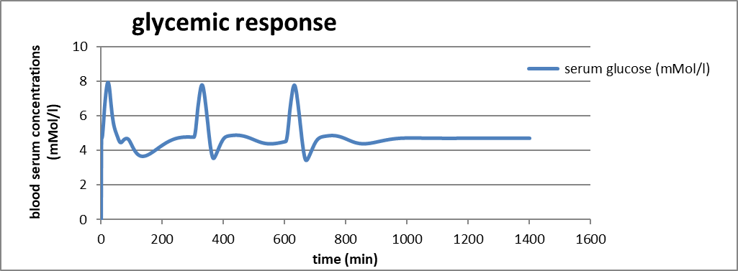
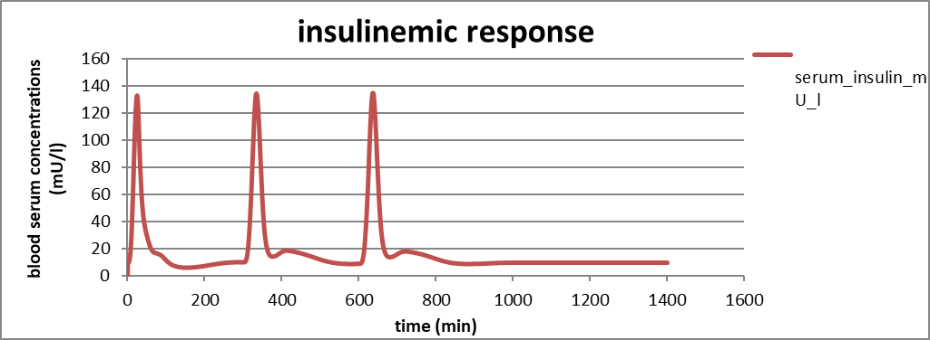
Competitive α-glucosidase inhibitor (such as acarbose) for maltase; concentration 100 x IC₅₀ in water
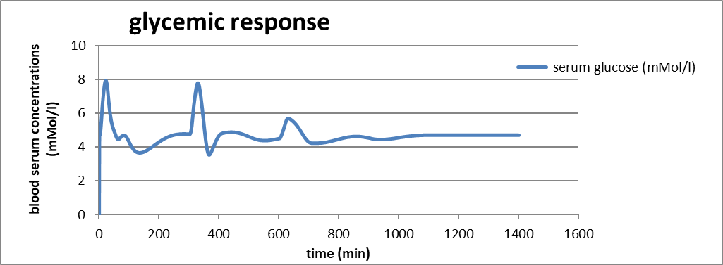
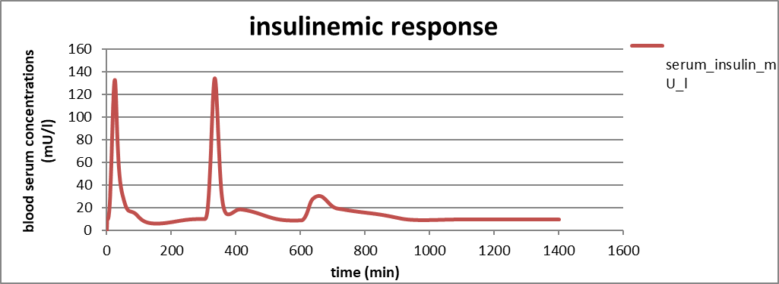
Starch in solid meals:
- 50 g glucose + 250 ml water; pH 7; maximum consumption speed 50 ml/min.
- 25 g bread (67 g water 50 g RDS, 9 g fat, 6 g protein) + 58 ml water; maximum consumption speed 50 ml/min.
- 25 g bread (67 g water 50 g RDS, 9 g fat, 6 g protein) + 58 ml citric juice (3 % citric acid in water); maximum consumption speed 50 ml/min.
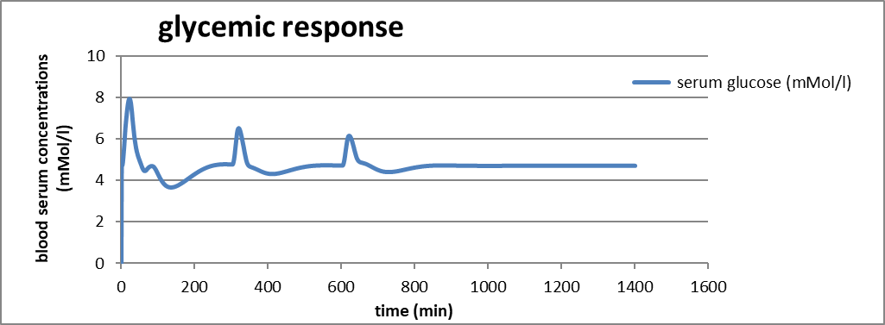
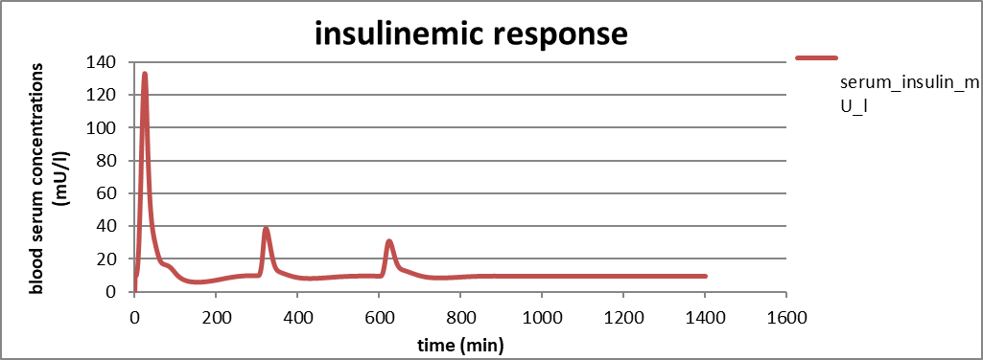
Study by Coby Eelderink
- 50 g glucose + 250 ml water; pH 7; maximum consumption speed 50 ml/min.
- 132 g bread (67 g water 50 g RDS, 9 g fat, 6 g protein) + 250 ml water; maximum consumption speed 50 ml/min.
- 119 g pasta (54 g water 50 g RDS, 9 g fat, 6 g protein) + 250 ml water; maximum consumption speed 50 ml/min.
